3GPP TSG RAN WG1 Meeting #125 R1-2604497
Dalian, China, May 18th – May 22nd, 2026
Agenda Item: 10.8.2
Source: Fraunhofer IIS, Fraunhofer HHI
Title: Aspects of Integrated sensing and communication for 6G ISAC
Document for: Discussion

1. Introduction
In [1], the study on Integrated Sensing and Communication (ISAC) for NR Release 20 investigates sensing performance evaluation using existing NR downlink waveforms and reference signals as baseline sensing signals. In addition, in RAN1#124bis [2], the following agreements were made for sensing reference signals and measurement reporting:
Agreement:
- On RS for ISAC, study at least the following aspects, considering sensing performance, resource overhead and impact to communication
  - RS for communication is reused for sensing
  - Enhanced RS for sensing, taking reuse of RS for communication as starting point
    - Note: Part of or all of the RS may be used for communication purposes, and it does not mean the final decision on whether the enhanced RS is used for communication purposes is to be made in this agenda.
  - Dedicated RS for sensing

Agreement:
- Study RE patterns of RS for sensing, considering sensing performance, resource overhead and impact to communication
- Note: enhancements on RS sequence if any will be discussed in agenda 10.8.3

Agreement:
- On measurement for ISAC, study at least the following aspects.
  - Measurement definitions/levels for TRP-side measurement, taking the measurement Levels studied in NR ISAC as starting point
  - Measurement definitions/levels for UE-side measurement
  - Impacts of non-ideal factors on measurement
  - Other aspects are not precluded
  - Note: this discussion may or may not mean there is specification impact

Agreement:
- On measurement report for ISAC, study at least the following aspects and applicable scenarios (e.g., sensing modes, targets, etc.) from RAN1 perspective.
  - Measurement reporting mechanism from UE
    - Option 1A: The UE measurements and/or assistance information if needed from UE can be directly sent to aNB
    - Option 1B: The UE measurements and/or assistance information if needed from UE can be sent to SF
  - Measurement reporting mechanism from aNB
    - Option 2A: The aNB measurements and/or assistance information if needed from aNB can be directly sent to UE
    - Option 2B: The aNB measurements and/or assistance information if needed from aNB can be sent to SF
  - The study may require cross-WG coordination.
  - Note: combination of multiple options is not precluded.
  - Note: measurements in each option may be different

Agreement:
- On measurement report for ISAC, study impacts from at least the following aspects from RAN1 perspective
  - Measurement reporting mechanism
    - E.g., Periodic, semi-persistent, aperiodic, event-triggered report as starting point
    - Reporting signaling e.g., L1, L2, higher layer, etc.
  - Other aspects are not precluded
  - The study may require cross-WG coordination

In this regard, our focus is placed on reference signal design and reporting/precoding mechanisms for ISAC.

2. Reference signal for ISAC
The agreed study on RE patterns of RS for sensing provides a starting point for considering sensing-oriented time-frequency resource structures. In addition to the pattern itself, it may be useful to study how such patterns are indicated to the UE and/or sensing receiver with reasonable signaling overhead. This is especially relevant when the RS pattern is non-uniform in time or frequency, or when different regions of a BWP, sensing window, or CPI require different RS densities.
For example, instead of indicating individual REs, the network may indicate region-specific parameters for different frequency regions, time regions, or time-frequency regions. Such parameters may indicate RS density, RS presence or absence, comb-related information, or mapping behavior for each region. This may allow denser RS allocation in regions requiring higher sensing accuracy, while keeping lower overhead or communication-prioritized allocation in other regions.
Proposal 1: Study indication mechanisms for RS patterns for sensing.
For ISAC, RS for sensing may not always be configured or controlled by a single network node. In some cases, sensing requirements, RS configuration decisions, resource allocation, and RS transmission/reception may involve different network nodes, such as sensing-related network entities, gNBs/aNBs, TRPs, or other RAN/CN entities. In addition, RS for sensing may need to coexist with ommunication-related configurations in the same carrier, BWP, slot, or resource grid. Therefore, it may be useful to study coordination mechanisms for configuration and operation of RS for sensing.
Such coordination may include alignment of sensing requirements, node capabilities, available resources, and RS configuration responsibilities among different network nodes. The configuration of RS for sensing may also need to be coordinated with communication-related configurations, so that sensing operation can be supported while limiting impact on communication transmission. For example, a higher-level network entity may provide sensing-related requirements or coordination information, while a RAN node may determine detailed RS configuration and resource usage according to local radio and communication conditions.
Proposal 2: Study coordination mechanisms for RS for sensing among different network entities and with communication-related configurations.

3. Measurement report and assistance information
Based on the above agreements, we believe that some further discussion is needed on how ISAC measurement reporting can be supported in practice, especially considering different reporting contents, reporting overhead, signaling procedures, and assistance information under different sensing modes and use cases. In the following, we discuss several aspects that may be useful for further RAN1 study.

3.1 Overhead Reduction
According on previous NR ISAC study [1], sensing measurement reports may be represented at different levels, ranging from raw or minimally processed sensing data to profile-level, detection-level, or target-level information. These reporting levels may have significantly different payload sizes and latency requirements. For example, raw or profile-level information may provide richer sensing information but may introduce larger reporting overhead, while detection-level or target-level information may reduce payload size but may provide less detailed intermediate information.
In addition, different sensing use cases may have different reporting requirements. For example, initial detection may tolerate coarse or reduced reporting, while target tracking or sensing refinement may require more frequent or more accurate reporting. Therefore, overhead reduction may need to consider the reporting level, reporting granularity, latency requirement, and sensing use case.
Possible mechanisms may include reduced reporting, subset reporting, differential reporting, relative-value reporting, unequal bit allocation, priority-based selection, or multi-layer carriage of sensing reports. For example, a low-latency sensing indication may be carried using a small number of bits, while detailed measurement information may be transmitted later using a larger-payload channel. Similarly, only changed or high-priority sensing information may be reported when uplink resources are limited.
Proposal 3: Study overhead reduction mechanisms for ISAC measurement reporting according to payload size, latency requirement, or reporting priority.
3.2 Configuration and triggering
For ISAC measurement reporting, configuration procedures may need to support different sensing modes, sensing use cases, and UE roles. For example, measurement configuration and reporting configuration may be jointly configured or separately configured. The configuration may indicate reporting level, reporting granularity, reporting timing, reporting format, applicable sensing resources, and whether the reporting is associated with UE-side measurement, network-side measurement, or UE-assisted sensing operation.
In addition to configuration, triggering procedures may need to be studied for sensing measurement and sensing reporting. Sensing measurement and sensing reporting may be triggered jointly or separately, and the triggering behavior may depend on sensing mode, sensing operation, reporting requirement, and resource availability. The triggering may be initiated or controlled by the network, for example through configuration, activation, or dynamic triggering, or may be requested by the UE based on locally observed sensing-related or communication-related conditions.
Furthermore, UE request and network response procedures may be considered to support flexible sensing reporting. For example, the UE may request or indicate a need for sensing measurement, sensing reporting, or reporting adaptation, while the network may control the final execution through configuration, triggering, or resource scheduling.
Proposal 4: Study configuration and triggering procedures for ISAC measurement reporting for different sensing modes and sensing use cases.
3.3 Assistance Information
In addition to sensing measurement results, assistance information may be useful for ISAC measurement and reporting. The purpose of such assistance information may be to improve sensing performance, assist the network in interpreting sensing reports, support network-side decisions on whether, when, and how to perform sensing measurement or reporting, or enable adaptation of sensing measurement and reporting configurations.
The assistance information may depend on sensing mode, sensing use case, UE role, and reporting mechanism. For example, the role and usefulness of assistance information may be different depending on whether the UE directly obtains sensing measurements or only participates in the sensing operation. Therefore, it may be beneficial to study what types of assistance information are needed under different sensing scenarios and how such information supports measurement and reporting operation.
The assistance information may be used to support network interpretation, measurement/reporting feasibility assessment, and adaptation of sensing measurement or reporting behavior. For example, such information may help the network understand the context of a reported measurement, determine whether additional measurement or reporting is needed, or adjust subsequent sensing-related configuration.
Proposal 5: Study assistance information for ISAC measurement and reporting for improving sensing performance and facilitating network-side measurement/reporting decisions.

4. On precoding enhancements for 6GR ISAC
Integrated sensing and communication (ISAC) is considered a key pillar of 6GR. For radar sensing applications, precoding is essential to illuminate the radar objects in rich clutter environments. In 5G NR, precoding is designed for communication purposes only. Radar sensing requires other requirements to meet detection performances. In this contribution, we address the precoder design for radar sensing requirements.
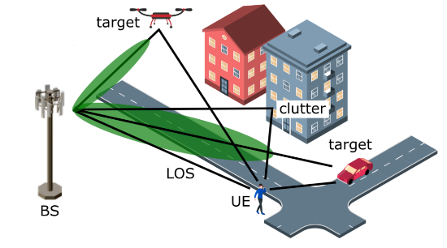
Figure 1: Bistatic radar setup.
A bistatic setup utilizing downlink resources for radar sensing, as shown in Fig 1. Is considered. It is assumed that a gNB is transmitting sensing reference signals that are used by the UE for channel measurements and reporting of precoder and/or sensing information. With the reported precoder information, the gNB precodes the sensing reference signals to improve the UE’s detection performance of the echoes/targets in the channel. One of the main problems in bistatic setups is typically the presence of a strong Line-of-Sight (LOS), and/or strong multipath components in the channel. These components refer to the clutter, because they degrade the detection of the echoes/targets at the UE. In Fig. 2, a typical power delay spectrum of a channel for a bistatic setup is shown. The LOS of the channel is dominant, whereas the relatively weak radar echo (referred to as “target” in the figure) is below the background components and hence difficult to detect at the UE. With the information on the clutter components of the channel, the gNB may precode the sensing reference signals in such a way that the power of the dominant LOS and clutter components is reduced so that the echo/target components are detectable at the UE.
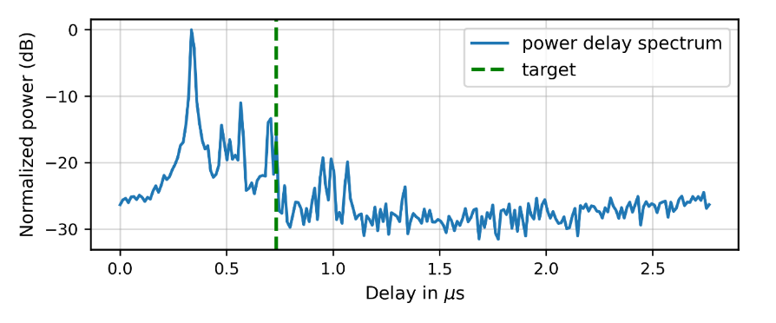
Figure 2: Power delay spectrum of a channel for an urban micro scenario (fc=5GHz, SCS=30kHz, B=80MHz).
We assume that the UE has some prior knowledge about the location of the echoes/targets in the channel. Such information may be obtained through a beam sweeping procedure between the gNB and UE. For example, the gNB may precode multiple sensing reference signals where each reference signal illuminates a specific area/region of interest in the channel. By transmitting multiple precoded sensing reference signals, a large area of interest can be monitored by the UE.
In 5G NR, a number of codebooks for CSI reporting were standardized across many releases. These codebooks are specified to support the evolution of MIMO from small to large antenna arrays and leverage the channel/precoder characteristics in spatial, frequency and time domains and also to support the multi-coordinated TRP scenarios. The Type-I and Type-II codebooks standardized in Rel. 15 exploit only the spatial correlation of the channel/precoder, whereas the Rel. 16 eType-II codebook exploits the channel/precoder correlation in spatial and frequency domain. The Rel. 16 eType-II codebook is very flexible and based on a combination of several DFT beams and delay (or frequency domain) components, which allows precoding in both space/delay domains.
We adapt the current CSI framework in 5G NR and the Rel. 16 eType-II codebook for our purpose. The difference in communication is the precoder selection procedure for radar sensing. Whereas in communication, the goal is to maximize spectral efficiency, the goal in radar sensing is to detect the particular echo/target components in the channel that have electromagnetically interacted with radar objects. The Rel. 16 eType-II precoder is defined by
$$W=W_{1}W_{2} W_{f}^{H} ∈C^{2N_{1}N_{2}×N_{3}},$$
where $W_{1}$ comprises the spatial components ($L$ DFT beam vectors), $W_{2}$ is a coefficient matrix, and $W_{f}$ comprises the delay components ($M$ beam vectors). Moreover, $N_{1}$ and $N_{2}$ denote the number of antenna ports in the first and second dimensions, and $N_{3}$ is the number of subbands of the precoder. The precoding matrix $W_{1}$ can be expressed by
$$W_{1}=\left[\begin{matrix}B & 0 \\ 0 & B \end{matrix}\right],$$
where B = [$v_{0}, {…, v}_{L-1}$] contains $L$ spatial DFT vectors, each of size $2N_{1}N_{2}×1$, for each polarization of the gNB’s antenna array. The matrix $W_{2}$ is of size $L×M$ and comprises the combining coefficients of the precoder. The matrix $W_{f}=[f_{0}, …, f_{M-1}]$ contains $M$ delay DFT vectors, each of size $N_{3}×1$, defined across the $N_{3}$ subbands.
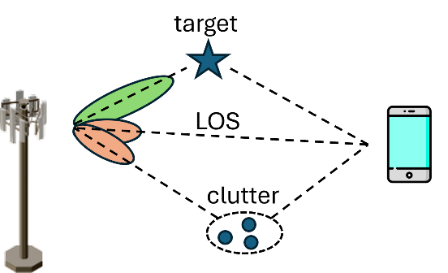
Figure 3: $L_{c}$ spatial DFT beams of the precoder are used to suppress the LOS component and clutter components of the channel (orange), and $L_{r}$ spatial DFT beams of the precoder are used to illuminate the target (green).
The concept of the proposed precoder is shown in Fig. 3. The precoder is based on $L=L_{c}+L_{r}$ spatial DFT beams and $M$ delays. $L_{c}$ spatial DFT beams together with $M$ delays are used in such a way to filter out the LOS and clutter components of the channel. The $L_{c}$ spatial DFT beams together with $M$ delays are combined to create sharp spatial nulls in the radiation pattern by destructive superposition. These nulls in the radiation pattern reduce the power of the LOS and clutter components of the channel. The $M$ delays of the precoder further increase the degrees of freedom in suppressing the clutter. They effectively create delayed versions of the precoded signal to cancel out clutter in a particular delay region of interest. The remaining $L_{r}$ spatial DFT beams together with the $M$ delays are used to illuminate a specific region of interest where one or more targets are assumed to be located.
Simulation results are provided in the following to illustrate the performance of the proposed procedure. The system parameters of the simulations are provided in the table in the Appendix. An example of the radiation pattern of the precoder is shown in Fig. 4 when $L_{c}=L_{r}=1$ and $M=9$.
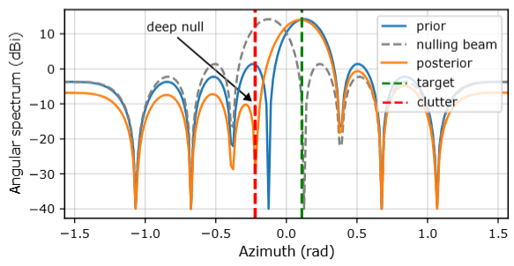
Figure 4: Radiation pattern of the precoder when $L_{c}=L_{r}=1$ and $M=9$.
The precoder is based on the two DFT beams [$v_{0}$, $v_{1}]$. The blue line (prior) illustrates the beam pattern of the first beam $v_{0}$ which is used to monitor an area of interest in the environment. The dashed line corresponds to the second beam $v_{1}$ which is selected in such a way to suppress the strong LOS by creating a null in the corresponding direction of the radiation pattern. The orange curve (posterior) represents the beam pattern of the combed L=2 spatial DFT vectors together with the M delays. The resulting beam pattern consists of a deep null towards the LOS direction, while increasing the power in the area of interest where the target may be located.

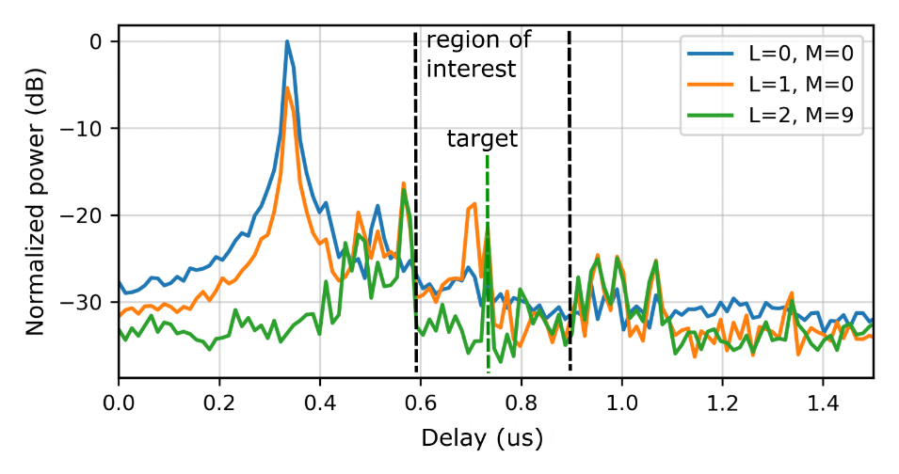
Figure 5: Power delay spectrum of the precoded signal in a bistatic radar setup.

An example of the resulting power delay spectrum (PDS) is shown in Fig.5. The blue curve corresponds to the unprecoded signal, while the orange line represents a single radar beam configuration with $L=L_{r}=1$. The green curve illustrates the precoder with the proposed selection procedure and configuration of $L=L_{r} {+ L}_{c}=1+1$ spatial beams together with $M=9$ delay components. The area of interest, where clutter suppression is targeted, is indicated by dashed black lines. The ground truth of the target echo is marked by a green dashed line. The strong LOS at 3.5 $μs$ is suppressed by 30 dB. Furthermore, clutter components in the region of interest are suppressed by 10 – 20 dB, while the target echo at $0.75 μs$is enhanced by approximately 16 dB.
The delay-Doppler map of the received signal is illustrated in Fig. 6, without a precoder (left) and with a precoder (right). The first signal component at 100 m is the LOS, which is suppressed by the precoded signal. The clutter region around the radar echo is also suppressed in the radargram of the precoded signal. At the same time, the radar echo at 150 m and -7 m/s is enhanced by 16 dB. Both make it easier for the UE to detect and accurately estimate the echo. Especially if radar resources are scarce and the radar echo cannot be resolved in the Doppler domain sufficiently to be separated from static clutter, the proposed precoder selection procedure enables the detection of the radar target.
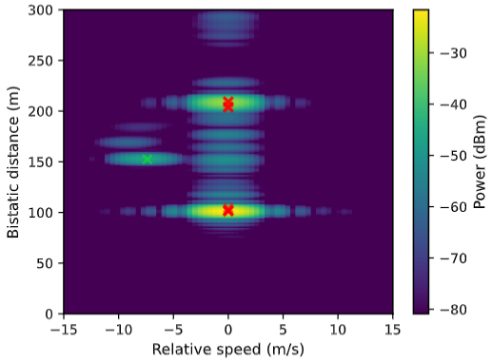 | 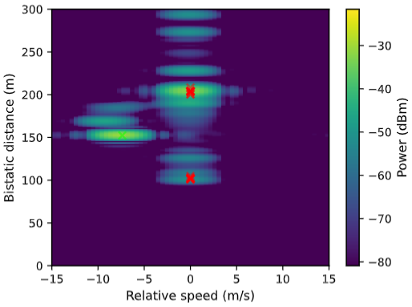
Figure 6: Delay-Doppler map of an unprecoded signal (left) and a precoded signal (right) with the target ground truth (green cross) and detected strong clutter components.

Proposal 6: Study precoding and reporting mechanisms for sensing for 6GR ISAC applications

5. Conclusion
From the above discussions on sensing reference signals and precoding for ISAC, the following views are provided.
Proposal 1: Study indication mechanisms for RS patterns for sensing.
Proposal 2: Study coordination mechanisms for RS for sensing among different network entities and with communication-related configurations.
Proposal 3: Study overhead reduction mechanisms for ISAC measurement reporting according to payload size, latency requirement, or reporting priority.
Proposal 4: Study configuration and triggering procedures for ISAC measurement reporting for different sensing modes and sensing use cases.
Proposal 5: Study assistance information for ISAC measurement and reporting for improving sensing performance and facilitating network-side measurement/reporting decisions.
Proposal 6: Study precoding and reporting mechanisms for sensing for 6GR ISAC applications.

References
- TR 38.765, “Study on Integrated Sensing and Communication (ISAC) for NR (Release 20)
- Chairman’s note, 3GPP TSG RAN WG1 #124bis, St. Julian’s, Malta, April 13 -17, 2026.
- 3GPP RAN#109, Revised SID: Study on 6G Radio, RP-252912

Appendix

Table 1: Simulation parameters
Parameter |  | Value
Duplex, Waveform |  | FDD, OFDM
Multiple access |  | OFDMA
ISD |  | 600 m
Scenario |  | Urban micro
Frequency range |  | 5 GHz
Channel generation |  | According to the TR 38.901
Antenna setup and port layouts at gNB |  | 32 ports: (8,4,1,1,1), (dH, dV) = (0.5$λ$,0.5$λ$)
Antenna setup and port layouts at UE |  | 1 ports: (1,1,1,1,1), (dH, dV) = (0.5$λ$,0.5$λ$)
Numerology | Slot/non-slot | 14 OFDM symbol slot
 | SCS | 30kHz
Simulation bandwidth |  | 100 MHz
UE receiver |  | MMSE-IRC
CSI feedback |  | CSI feedback periodicity: 5 ms  Scheduling delay: 4 ms
Feedback assumption |  | Realistic
Channel estimation |  | Realistic

